Self-Assessment: How Well Do You Recognize and Regulate Emotions?

Sources: Copyright © 2011 Steven L McShane. This self-assessment was inspired by similar instruments, particularly: N. S. Schutte, et al, "Development and validation of a measure of emotional intelligence", Personality and Individual Differences 25, no. 2 (1998): 167–177; C-S Wong and K. S. Law, "The effects of leader and follower emotional intelligence on performance and attitude: An exploratory study", Leadership Quarterly 13 (2002): 243–274; P. J. Jordan, and S. A. Lawrence, "Emotional intelligence in teams: Development and initial validation of the short version of the Workgroup Emotional Intelligence Profile (WEIP-S)", Journal of Management & Organization 15 (2009): 452–469.

Purpose: This self-assessment is designed to help you understand the meaning and dimensions of emotional intelligence and to estimate your perceptions of your emotional intelligence.

Overview: Emotional intelligence has become an important concept and ability in the workplace. It is a skill that people develop throughout their lives to help them interact better with others, make better decisions, and manage the attitudes and behavior of other people. Although emotional intelligence is best measured as an ability test, this scale offers you an opportunity to estimate your perceptions and self-awareness of this ability in yourself.

Instructions: Read each of the statements below and select the response that best describes you. This self-assessment is completed alone so that students rate themselves honestly without concerns of social comparison. However, class discussion will focus on the meaning and dimensions of emotional intelligence, its application in the workplace, and the best ways to measure emotional intelligence.

MY RESULTS
Self-awareness of emotions
Score : 17 pts.
16-20Feedback : This scale measures the four dimensions of emotional intelligence described in this book. Scores on the four Emotional Intelligence Self-Assessment dimensions range from 4 to 20. The overall score ranges from 16 to 80. Norms vary from one group to the next. The following table shows norms from a sample of 75 MBA students in two countries (Australia and Singapore). For example, the top 10 percentile for Self-awareness of emotions is 19, indicating that 10 percent of people score 19 or 20 and 90 percent score below 19 on this dimension. Keep in mind that these scores represent self-perceptions. Evaluations from others (such as through 360-degree feedback) may provide a more accurate estimate of your emotional intelligence on some (not necessarily all) dimensions. The four dimensions are defined as follows:

High

This is the ability to perceive and understand the meaning of your own emotions.
Self-management of emotions
Score : 12 pts.
10-15Feedback : Average

This is the ability to manage your own emotions. It includes generating or suppressing emotions and displaying behaviours that represent desired emotions in a particular situation.
Awareness of others' emotions
Score : 9 pts.
4-9Feedback :
Low

This is the ability to perceive and understand the emotions of other people, including the practices of empathy and awareness of social phenomena such as organizational politics.
Management of others' emotions
Score : 14 pts.
10-15Feedback : Average

This is the ability to manage other people's emotions. It includes generating or suppressing emotions in other people, such as reducing their sadness and increasing their motivation.

QUESTION 1
- a. A recent study reported that university instructors are frequently required to engage in emotional labor. Identify FOUR situations in which emotional labor might be required for this job.
- While handling the parents of a learner who had several encounters of misconduct.
- While deciding a mid-term break on the equals' request will negatively impact the student's interest.
- While telling a workmate, he is using the wrong approach to teach the students.
- While handling a student who thinks the teacher has inadequate knowledge.

b. Look over exhibit 4.1 (wheel of emotions, page 80). Using the general descriptions inside the circle (high negative, etc), choose which emotion you feel most be most beneficial or most likely exhibited in the following situations: (explain your choices)

  - a college professor giving a lecture
  - a nurse checking in on a sick patient
  - a flight attendant when the plane is experiencing turbulence
  - a student studying for a test in a library
  - a 911 dispatcher responding to a call about a house fire

Tips:
a. For each one discuss why emotional labor would be required.
b. Choose one general response from inside the circle for each and explain why you feel it is appropriate.

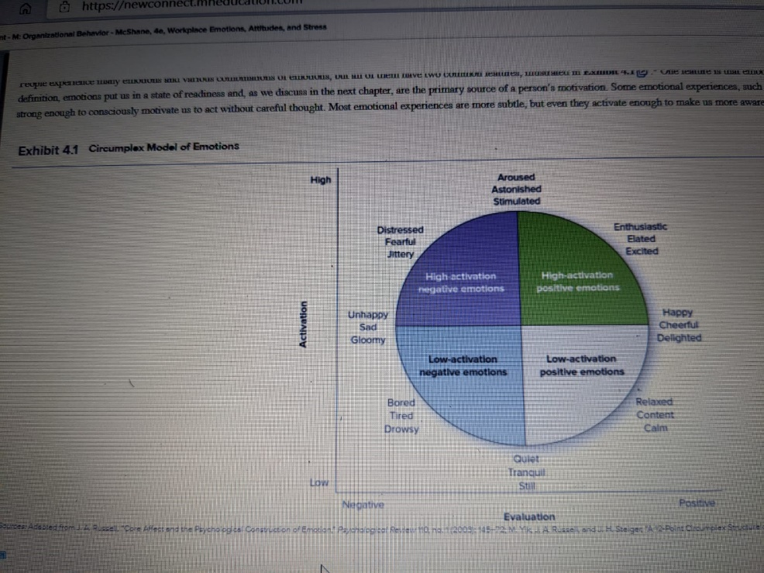
Emotional labor is challenging for a university instructor due to the nature of the working environment. The instructor's job becomes vital since the individual's career deals with the student's future. Such positions require individuals to behave differently. Instructors are seen as role models by the members of the community and the student. Such situations require the teachers to exceed set expectations.

QUESTION 2
Two college graduates recently joined the same major newspaper as journalists. Both work long hours and have tight deadlines for completing their stories. They are under constant pressure to scout out new leads and be the first to report contemporary controversies. One journalist is increasingly exhausted and discouraged and has taken several days of sick leave. The other is getting the work done and seems to enjoy the challenges. Use your knowledge of stress to explain why these two journalists are reacting differently to their jobs.
Stress can either be a threat or a motivator for a person depending on how the individual deals with the stressor and the factors that constitute the reaction. The stressor from both parties, however, the perceived stress is different. The confident journalist handled his pressure with high self-esteem, resilience, and confidence. On the other hand, the other journalist handled suffered from low performance and morale, and anxiety. The confident journalist kept the stress at a minimal level, thus taking it with ease. He enjoys dealing handling his task as the stress triggers passion and perseverance.

QUESTION 3
- Shanaya is a new manager without experience. Her staff has been highly dissatisfied, which is why the previous manager was dismissed.
  - What would you tell Shanaya about the impact of job satisfaction on performance?
Job satisfaction creates an understanding of performance in any firm. Workers' performance enhancements deserve a better working environment, which can easily lead to job satisfaction. The satisfaction determines the workers' level of expectation. Job satisfaction impacts the worker's efforts and plays a role in increasing performance. It also influences a worker's ability to complete the task at hand .high job satisfaction leads to improved attendance, high productivity, and low unionization. Workers who share effective relationships with their leaders have comfort and satisfaction in handling their tasks.
  - Explain to Shanaya four likely outcomes due to job dissatisfaction. (hint: use a model in the text).
Job dissatisfaction results in high turnover rates. Workers who are not satisfied with their job usually find a better job environment. Secondly, dissatisfied workers are more likely to place less importance on their work. It is also the primary reason for the unionization of employees. Job dissatisfaction also creates low productivity. in most cases, the employees get stressed up, leading to reduced dedication and loyalty.
  - Discuss four ways Shanaya can increase employee commitment.
Several ways can be utilized to increase employee commitment, such as providing clear objectives of the firm, which helps the workers cooperate with organization aims. Also, Shanaya should ensure that the tasks are allocated to the correct employees. There should also be special attention to the development and growth of workers. Shanaya should also use a flexible approach in managing the workers. Lastly, strong communication offers the workers a chance to provide their insights about the organization and its needs.
  - Shanaya wonders about different types of employee commitment. Explain these to her. Is one of these preferable? Explain.
Normative commitment reflects the feeling of obligation to with the employment. This type of commitment is built upon values, degrees, and duties to which a worker stays in the firm.
Continuance commitment- This type of commitment involves the situation where the worker finds the firm supportive and positive; thus, the individual will create a high level of commitment. This type of commitment deals with a lack of alternatives and investment.
Affective commitment refers to the worker’s involvement and emotional attachment with the firm. This type of employee commitment is preferable to any organization since its basis is how the employee likes or feels to be a part of an organization.

QUESTION 4
can lead to Ruka is discussing with her manager Thomas. She is explaining to him that employee satisfaction greater profitability. Thomas is uncertain. What evidence can Ruka cite to strengthen her argument?
Hint: you need to refer to a specific model in your text.
Employee satisfaction makes the workers care more, and they become productive; also, they get a stronger will to last in their jobs longer. Job satisfaction also leads to happier clients, who will prefer the firm more often and buy more, increasing the sales resulting in higher profits. Worker satisfaction translates to tangible effects that lead to the firm's increased success and profitability. By lowering turnover rates, the number of new workers is reduced, saving training new workers.

QUESTION 5
Review your results for the Emotional Intelligence (EI) self-assessment, then please respond to the following:
- What were your scores for the four areas of EI? For each - do you agree or disagree? Why or why not?
High
Self-management of emotions
Score: 12 pts.
10-15Feedback: Average
Awareness of others' emotions
Score: 9 pts.
4-9 Feedback:
Low
Management of others' emotions
Score: 14 pts.
10-15 Feedback: Average
I agree with the above-stated result since the emotional test was carried out without any biases.
2. Discuss how you can improve your EI.
Emotional intelligence can be developed and learned. I can improve my EI by observing how I react to people. I can look at how I interact and think with other people. I can also try to be more accepting and open to other people's needs and perspectives. The different process involves recognizing my emotions and naming them. I can also ask for feedback from my friends and colleagues. i can also practice self-awareness for better management of my feelings.

QUESTION 6
> Think about your experiences recently or in the past. Describe for your classmates one incident in which you were "very stressed" due to each of the following: (i.e. you will identify one situation for each stressor):
- incivility
- work overload
- low task control
> How did you "deal with" (i.e. manage) your stress in each situation? How do you generally manage stress?
> For each - did you also need to engage in emotional labor? Explain

Just several weeks ago, I was in my room reading a novel about nature. However, I was stressed up by the loud music that was played by my younger brother from the home stereo. The music was irritating to my ears since I tried to concentrate on reading, but I failed.
Work overload occurs when the job demand exceeds a person’s ability to deal with them. in my previous work, I spend more than 7 hours weekly attending different meetings. This was a very stressful situation because of mental weariness. When I approached my supervisor about how the meeting's extended hours prevent me from handling other duties, he refused to reduce the meeting hours.
Low task control is a stressful condition in which an individual is expected to complete a task in which they have no control over the fundamental factors that influence the objective's outcome. When I was a cab driver, I remember a day I was supposed to get the client to his destination on time. However, due to a traffic jam, I was not able to reach the destination on time.
I dealt with the stress from loud music by holding my younger brother accountable for the issue. It was essential to address the disrespectful aspects when noted. After encountering challenges reading the novel, I took my brother aside, pointed out what he was doing, and explained why it was rude. After that, I encouraged him to be aware of his conduct at home. I handled stress from work overload by managing my time. I also made a list of every task that must be addressed. I also committed myself only to the crucial task. I dealt with stress from low task control by changing the stress perception and removing the stressors. I also got social support from my fellow workmates. In all three cases, I did not have to manage my expressions and feelings to fulfill the task's emotional requirement.

